**How to- New Case Prioritization**

**What you will need:**

1. Current MDSS download of new cases in past 3 days
2. Smartsheet download
3. “Facilities Masterlist” file. **This file is already saved and do not need to be downloaded.**
4. New Case Prioritization R code

**Setting up the folder C:/Case Pulls**

1. Download files from [Github](https://github.com/Detroit-Health-Epidemiology/CD-shared) and save them to folder
   1. Facilities masterlist.xlsx
   2. NewCasePrioritization_forCDteam.Rmd
2. Set up an Archive folder
3. Your set up should look like this

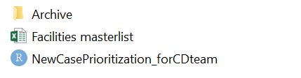

**Step 1 - MDSS Download:**

1. Go to “New Search” in MDSS
2. Case Status= **Confirmed + Probable**
3. Investigation Status= “New”
4. Reportable Condition= “Novel Coronavirus”
5. Referral Date= Past 3 days, on Mondays download past 4.
6. Local Health Jurisdiction= “Detroit City”, make sure to check primary jurisdiction box.

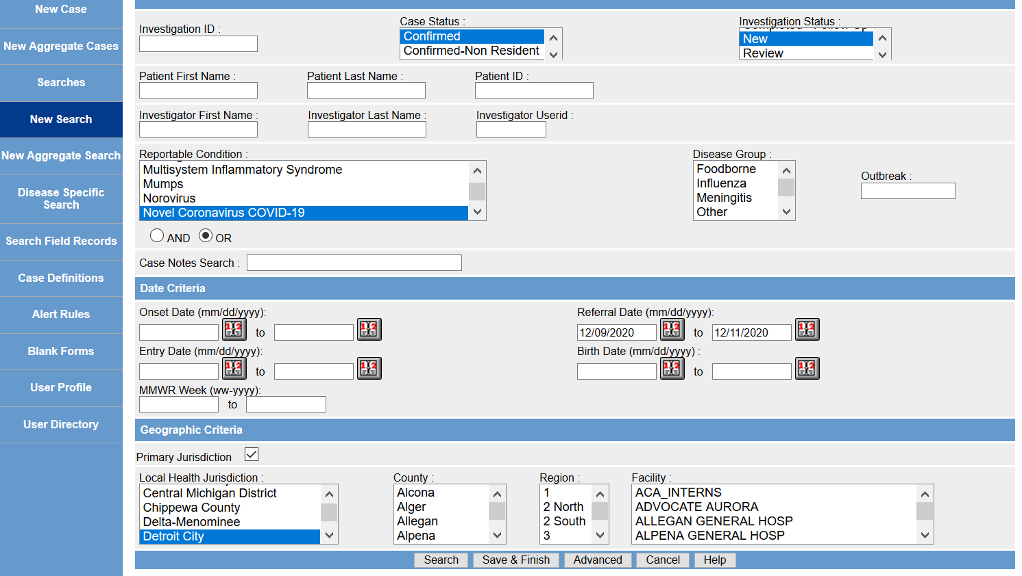

1. Export cases with labs, and save as “**NewCases.csv**” here: *C:\Case Pulls*

**Step 2 - Smartsheet:**

1. Export smartsheet as excel file: <https://app.smartsheet.com/sheets/JjVgQG5xhW2jF6f2p6GQJv7xmwMJgPrPXRHM6wH1?view=grid>
2. Save exported file as “**x_Investigation IDs Input.xlsx**” in *C:\Case Pulls*

**Step 3 – run code:**

1. Your folder should look like this the first time

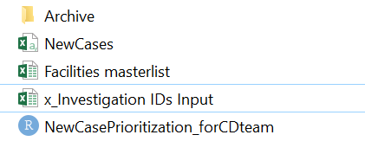

1. Open “NewCasePrioritization.rmd” and run
2. The folder should be a new file in your folder and you can move it to box (the file should also appear in your archive folder)

Case prioritization

* Inpatient
* Cases flagged for facilities
* Confirmed cases from yesterday
* Probable cases from yesterday
* Confirmed cases from today
* Probable cases from today
* Confirmed cases from two days ago
* Probable cases from two days ago
* Rest of cases in descending order based on Referral date